**30_07_2024 _MAD_Lecture – Q1**

**Explicit intent**

**Username and Password using intent for page linking.**

MainActivity.java

package com.example.a30_07_2024;

import android.content.Intent;

import android.os.Bundle;

import android.view.View;

import android.widget.Button;

import android.widget.EditText;

import android.widget.Toast;

import androidx.appcompat.app.AppCompatActivity;

public class MainActivity extends AppCompatActivity {

Button submit;

EditText usern;

EditText pass;

@Override

protected void onCreate(Bundle savedInstanceState) {

super.onCreate(savedInstanceState);

setContentView(R.layout.activity_main);

submit = (Button) findViewById(R.id.b1);

usern = (EditText) findViewById(R.id.val1);

pass = (EditText) findViewById(R.id.val2);

submit.setOnClickListener(new View.OnClickListener() {

@Override

public void onClick(View view) {

String user1 = usern.getText().toString();

String p = pass.getText().toString();

if (user1.equals("SIMMC") && p.equals("123")) {

Intent intent = new Intent(getApplicationContext(), MainActivity2.class);

intent.putExtra("key", user1);

startActivity(intent);

} else {

Toast.makeText(MainActivity.this, "Invalid username or password", Toast.LENGTH_SHORT).show();

}

}

});

}

}

Activity_main.xml

<?xml version="1.0" encoding="utf-8"?>

<RelativeLayout xmlns:android="http://schemas.android.com/apk/res/android"

xmlns:app="http://schemas.android.com/apk/res-auto"

xmlns:tools="http://schemas.android.com/tools"

android:id="@+id/main"

android:layout_width="match_parent"

android:layout_height="match_parent"

tools:context=".MainActivity">

<EditText

android:id="@+id/val1"

android:layout_width="wrap_content"

android:layout_height="wrap_content"

android:layout_alignParentEnd="true"

android:layout_alignParentBottom="true"

android:layout_marginEnd="152dp"

android:layout_marginBottom="571dp"

android:ems="10"

android:inputType="text"

android:hint="Enter your Username" />

<EditText

android:id="@+id/val2"

android:layout_width="wrap_content"

android:layout_height="wrap_content"

android:layout_alignParentEnd="true"

android:layout_alignParentBottom="true"

android:layout_marginEnd="155dp"

android:layout_marginBottom="480dp"

android:ems="10"

android:hint="Enter your Password"

android:inputType="textPassword" />

<Button

android:id="@+id/b1"

android:layout_width="wrap_content"

android:layout_height="wrap_content"

android:layout_alignParentEnd="true"

android:layout_alignParentBottom="true"

android:layout_marginEnd="268dp"

android:layout_marginBottom="357dp"

android:text="Submit" />

</RelativeLayout>

MainActivity2.java

package com.example.a30_07_2024;

import android.content.Intent;

import android.os.Bundle;

import android.widget.TextView;

import androidx.activity.EdgeToEdge;

import androidx.appcompat.app.AppCompatActivity;

import androidx.core.graphics.Insets;

import androidx.core.view.ViewCompat;

import androidx.core.view.WindowInsetsCompat;

public class MainActivity2 extends AppCompatActivity {

@Override

protected void onCreate(Bundle savedInstanceState) {

super.onCreate(savedInstanceState);

setContentView(R.layout.activity_main2);

Intent i = getIntent();

String s = i.getStringExtra("key");

TextView tv = (TextView) findViewById(R.id.tv);

tv.setText("Welcome " + s + " !!!!!!");

}

}

Activity_main2.xml

<?xml version="1.0" encoding="utf-8"?>

<RelativeLayout xmlns:android="http://schemas.android.com/apk/res/android"

xmlns:app="http://schemas.android.com/apk/res-auto"

xmlns:tools="http://schemas.android.com/tools"

android:id="@+id/main"

android:layout_width="match_parent"

android:layout_height="match_parent"

tools:context=".MainActivity2"

android:background="#756E7BC5">

<TextView

android:id="@+id/tv"

android:layout_width="wrap_content"

android:layout_height="wrap_content"

android:text="" />

</RelativeLayout>

Output:

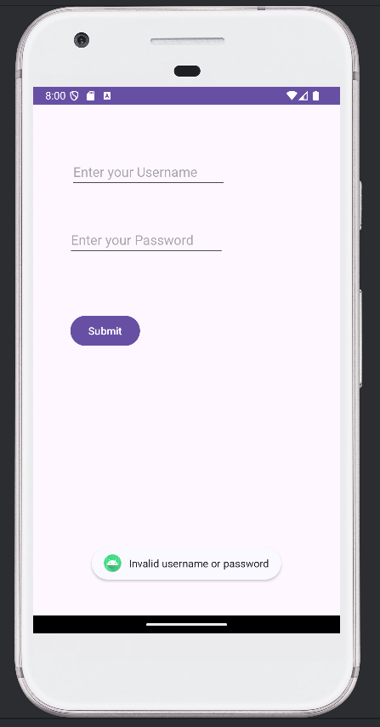 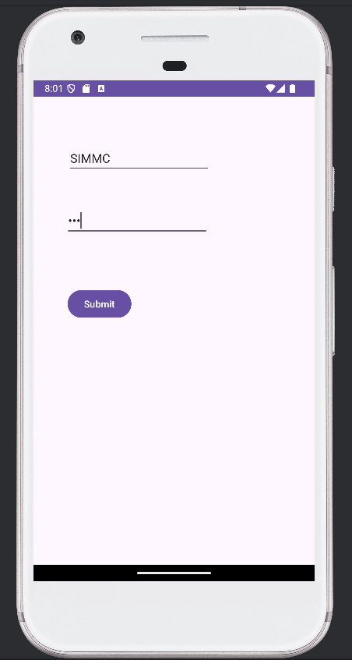

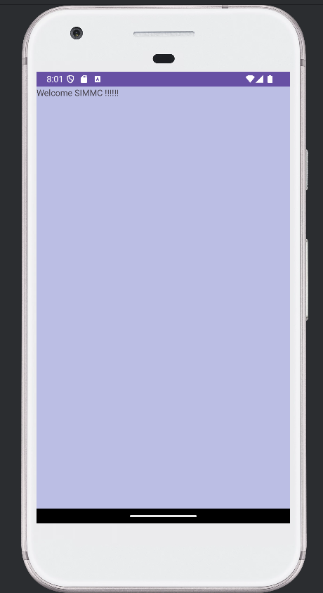

**02_08_2024 _MAD_Lecture – Q2**

**Implicit intent**

MainActivity.java

package com.example.a02_08_2024;

import android.content.Intent;

import android.net.Uri;

import android.os.Bundle;

import android.view.View;

import android.widget.Button;

import android.widget.EditText;

import androidx.appcompat.app.AppCompatActivity;

public class MainActivity extends AppCompatActivity {

EditText ed;

Button b1;

@Override

protected void onCreate(Bundle savedInstanceState) {

super.onCreate(savedInstanceState);

setContentView(R.layout.activity_main);

ed =(EditText) findViewById(R.id.ed);

b1 =(Button) findViewById(R.id.b1);

b1.setOnClickListener(new View.OnClickListener() {

@Override

public void onClick(View v) {

String url = ed.getText().toString();

Intent intent = new Intent(Intent.ACTION_VIEW,Uri.parse(url));

startActivity(intent);

}

});

}

}

Activity_main.xml

<?xml version="1.0" encoding="utf-8"?>

<RelativeLayout xmlns:android="http://schemas.android.com/apk/res/android"

xmlns:app="http://schemas.android.com/apk/res-auto"

xmlns:tools="http://schemas.android.com/tools"

android:id="@+id/main"

android:layout_width="match_parent"

android:layout_height="match_parent"

tools:context=".MainActivity">

<EditText

android:id="@+id/ed"

android:layout_width="409dp"

android:layout_height="75dp"

android:layout_alignParentEnd="true"

android:layout_alignParentBottom="true"

android:layout_marginEnd="0dp"

android:layout_marginBottom="632dp"

android:ems="10"

android:inputType="text"

android:hint="URL"

android:textAlignment="center" />

<Button

android:id="@+id/b1"

android:layout_width="match_parent"

android:layout_height="wrap_content"

android:layout_alignParentEnd="true"

android:layout_alignParentBottom="true"

android:layout_marginEnd="0dp"

android:layout_marginBottom="546dp"

android:text="Submit" />

</RelativeLayout>

Output:

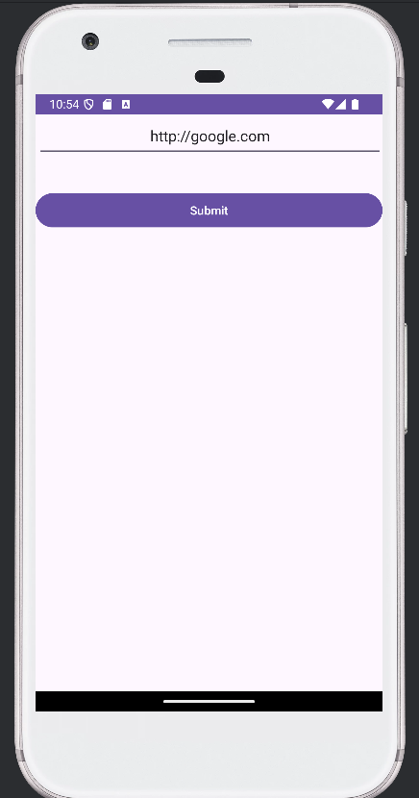 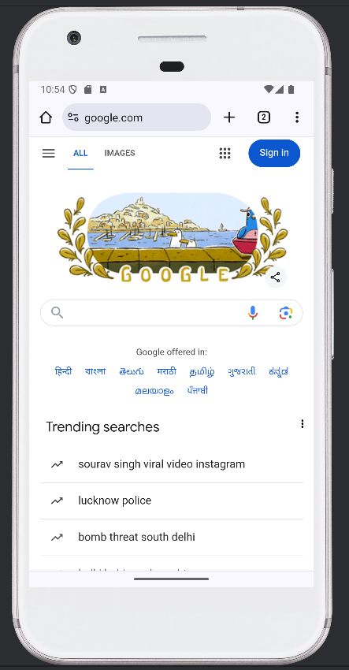

**02_08_2024 _MAD_Lecture -Q3**

**Android manifest file user permission and upload image**

MainActivity.java

package com.example.a02_08_2024;

import android.content.Intent;

import android.net.Uri;

import android.os.Bundle;

import android.view.View;

import android.widget.Button;

import android.widget.ImageView;

import androidx.annotation.Nullable;

import androidx.appcompat.app.AppCompatActivity;

public class MainActivity extends AppCompatActivity {

ImageView im;

Button b;

int SELECT_PICTURE = 1000;

@Override

protected void onCreate(Bundle savedInstanceState) {

super.onCreate(savedInstanceState);

setContentView(R.layout.activity_main);

im = findViewById(R.id.imageView);

b = findViewById(R.id.b1);

b.setOnClickListener(new View.OnClickListener() {

@Override

public void onClick(View view) {

Intent intent = new Intent();

intent.setType("image/*");

intent.setAction(Intent.ACTION_GET_CONTENT);

startActivityForResult(Intent.createChooser(intent, "SELECT PICTURE"), SELECT_PICTURE);

}

});

}

@Override

protected void onActivityResult(int requestCode, int resultCode, @Nullable Intent data) {

super.onActivityResult(requestCode, resultCode, data);

if (resultCode == RESULT_OK && requestCode == SELECT_PICTURE) {

// Get the Uri of the selected image

Uri selectedImageUri = data.getData();

if (selectedImageUri != null) {

im.setImageURI(selectedImageUri);

}

}

}

}

Activity_main.xml

<?xml version="1.0" encoding="utf-8"?>

<LinearLayout xmlns:android="http://schemas.android.com/apk/res/android"

xmlns:app="http://schemas.android.com/apk/res-auto"

xmlns:tools="http://schemas.android.com/tools"

android:id="@+id/main"

android:layout_width="match_parent"

android:layout_height="match_parent"

tools:context=".MainActivity"

android:orientation="vertical">

<LinearLayout

android:layout_width="match_parent"

android:layout_height="wrap_content"

android:orientation="horizontal">

<Button

android:id="@+id/b1"

android:layout_width="match_parent"

android:layout_height="wrap_content"

android:text="Button" />

</LinearLayout>

<ImageView

android:layout_width="match_parent"

android:layout_height="300dp"

android:layout_centerHorizontal="true"

android:layout_marginTop="50dp"

android:scaleType="centerCrop"

android:id="@+id/imageView"/>

</LinearLayout>

AndroidManifest.xml

<?xml version="1.0" encoding="utf-8"?>

<manifest xmlns:android="http://schemas.android.com/apk/res/android"

xmlns:tools="http://schemas.android.com/tools">

<uses-permission android:name="android.permission.READ_EXTERNAL_STORAGE"/>

<uses-permission android:name="android.permission.WRITE_EXTERNAL_STORAGE"/>

<application

android:allowBackup="true"

android:dataExtractionRules="@xml/data_extraction_rules"

android:fullBackupContent="@xml/backup_rules"

android:icon="@mipmap/ic_launcher"

android:label="@string/app_name"

android:roundIcon="@mipmap/ic_launcher_round"

android:supportsRtl="true"

android:theme="@style/Theme._02_08_2024"

tools:targetApi="31">

<activity

android:name=".MainActivity"

android:exported="true">

<intent-filter>

<action android:name="android.intent.action.MAIN" />

<category android:name="android.intent.category.LAUNCHER" />

</intent-filter>

</activity>

</application>

</manifest>

Output:

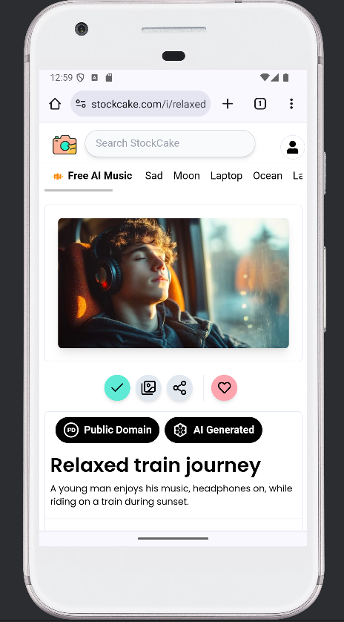 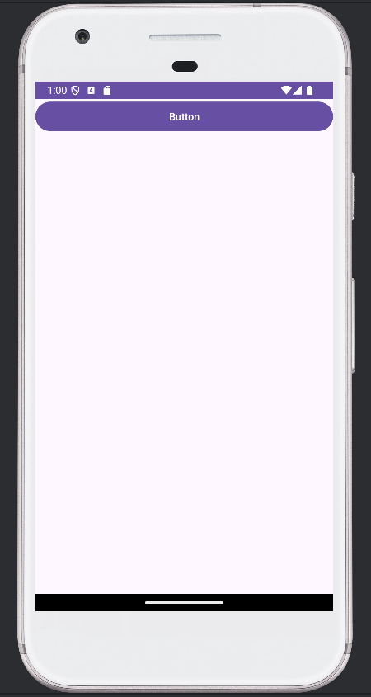

Download Image from google Click on Button

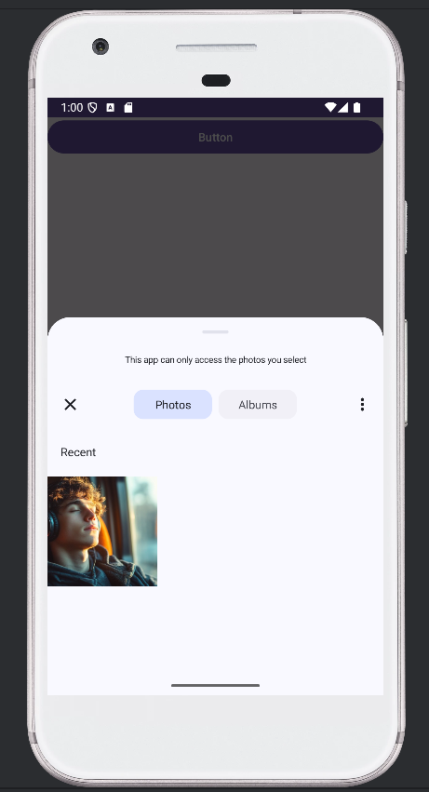 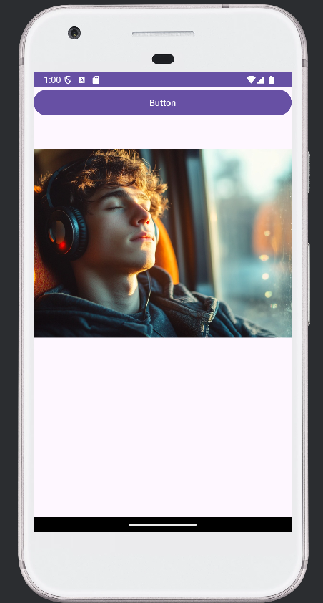

Select Image from downloads

**05_08_2024_MAD_Lecture – Q4**

**Listview using ArrayAdapter**

A. Simple List Item

MainActivity.java

package com.example.a05_08_204;

import android.os.Bundle;

import android.view.View;

import android.widget.Adapter;

import android.widget.AdapterView;

import android.widget.ArrayAdapter;

import android.widget.ListView;

import android.widget.Toast;

import androidx.appcompat.app.AppCompatActivity;

import androidx.core.graphics.Insets;

import androidx.core.view.ViewCompat;

import androidx.core.view.WindowInsetsCompat;

public class MainActivity extends AppCompatActivity {

ListView lv;

String[] subjects = {"CC","DWDM","MAD","STQA","KRAI"};

@Override

protected void onCreate(Bundle savedInstanceState) {

super.onCreate(savedInstanceState);

setContentView(R.layout.activity_main);

lv=(ListView) findViewById(R.id.listview);

ArrayAdapter<String> adapter=new ArrayAdapter<String>(getApplicationContext(), android.R.layout.simple_list_item_1,subjects);

lv.setAdapter(adapter);

lv.setOnItemClickListener(new AdapterView.OnItemClickListener() {

@Override

public void onItemClick(AdapterView<?> adapterView, View view, int i, long l) {

String s = adapter.getItem(i);

Toast.makeText(getApplicationContext(),s,Toast.LENGTH_SHORT).show();

}

});

}

}

Activity_main.xml

<?xml version="1.0" encoding="utf-8"?>

<LinearLayout xmlns:android="http://schemas.android.com/apk/res/android"

xmlns:app="http://schemas.android.com/apk/res-auto"

xmlns:tools="http://schemas.android.com/tools"

android:id="@+id/main"

android:layout_width="match_parent"

android:layout_height="match_parent"

tools:context=".MainActivity">

<ListView

android:layout_width="match_parent"

android:layout_height="match_parent"

android:id="@+id/listview"

/>

</LinearLayout>

Output:

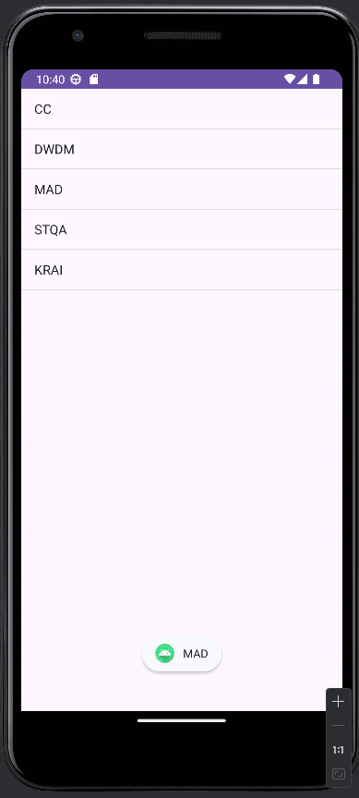

B. Simple List item with multiple choice

MainAcivity.xml

package com.example.a05_08_204;

import android.os.Bundle;

import android.view.View;

import android.widget.Adapter;

import android.widget.AdapterView;

import android.widget.ArrayAdapter;

import android.widget.Button;

import android.widget.ListView;

import android.widget.Toast;

import androidx.appcompat.app.AppCompatActivity;

import androidx.core.graphics.Insets;

import androidx.core.view.ViewCompat;

import androidx.core.view.WindowInsetsCompat;

public class MainActivity extends AppCompatActivity {

ListView lv;

String[] subjects = {"CC","DWDM","MAD","STQA","KRAI"};

@Override

protected void onCreate(Bundle savedInstanceState) {

super.onCreate(savedInstanceState);

setContentView(R.layout.activity_main);

lv=(ListView) findViewById(R.id.listview);

ArrayAdapter<String> adapter=new ArrayAdapter<String>(getApplicationContext(), android.R.layout.simple_list_item_multiple_choice,subjects);

lv.setAdapter(adapter);

lv.setChoiceMode(lv.CHOICE_MODE_MULTIPLE);

lv.setOnItemClickListener(new AdapterView.OnItemClickListener() {

@Override

public void onItemClick(AdapterView<?> adapterView, View view, int i, long l) {

String s = adapter.getItem(i);

Toast.makeText(getApplicationContext(),s,Toast.LENGTH_SHORT).show();

}

});

}

}

Activity_main.xml

<?xml version="1.0" encoding="utf-8"?>

<LinearLayout xmlns:android="http://schemas.android.com/apk/res/android"

xmlns:app="http://schemas.android.com/apk/res-auto"

xmlns:tools="http://schemas.android.com/tools"

android:id="@+id/main"

android:layout_width="match_parent"

android:layout_height="match_parent"

android:orientation="vertical"

tools:context=".MainActivity"

>

<ListView

android:id="@+id/listview"

android:layout_width="match_parent"

android:layout_height="692dp"

/>

<LinearLayout

android:layout_width = "wrap_content"

android:layout_height="wrap_content">

</LinearLayout>

<Button

android:id="@+id/b1"

android:layout_width="match_parent"

android:layout_height="match_parent"

android:text="Display" />

</LinearLayout>

Output:

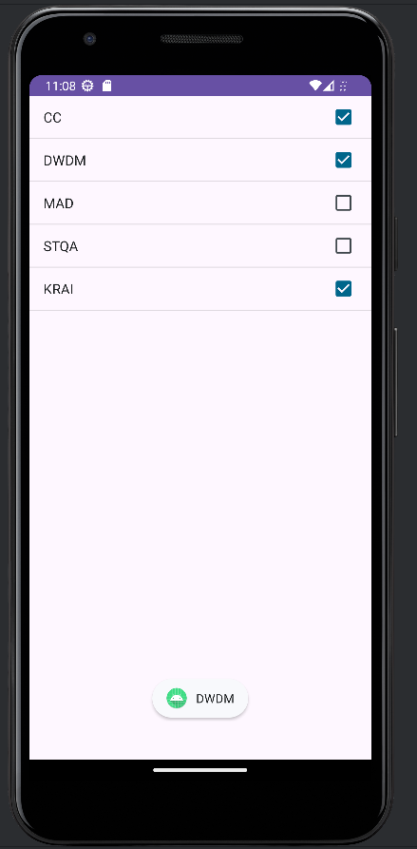

C . To Display multiple choice list using toast

MainActivity.xml

package com.example.a05_08_204;

import android.os.Bundle;

import android.view.View;

import android.widget.AdapterView;

import android.widget.ArrayAdapter;

import android.widget.Button;

import android.widget.ListView;

import android.widget.Toast;

import androidx.appcompat.app.AppCompatActivity;

public class MainActivity extends AppCompatActivity {

ListView lv;

Button btn;

String[] subjects = {"CC","DWDM","MAD","STQA","KRAI"};

@Override

protected void onCreate(Bundle savedInstanceState) {

super.onCreate(savedInstanceState);

setContentView(R.layout.activity_main);

lv = findViewById(R.id.listview);

btn = findViewById(R.id.b1);

ArrayAdapter<String> adapter = new ArrayAdapter<>(this, android.R.layout.simple_list_item_multiple_choice, subjects);

lv.setAdapter(adapter);

lv.setChoiceMode(ListView.CHOICE_MODE_MULTIPLE);

btn.setOnClickListener(new View.OnClickListener() {

@Override

public void onClick(View view) {

int count = lv.getCount();

StringBuilder selectedItems = new StringBuilder();

for (int i = 0; i < count; i++) {

if (lv.isItemChecked(i)) {

selectedItems.append(adapter.getItem(i)).append(", ");

}

}

if (selectedItems.length() > 0) {

selectedItems.setLength(selectedItems.length() - 2);

}

Toast.makeText(getApplicationContext(), "Selected: " + selectedItems.toString(), Toast.LENGTH_SHORT).show();

}

});

}

}

Activity_main.xml

<?xml version="1.0" encoding="utf-8"?>

<LinearLayout xmlns:android="http://schemas.android.com/apk/res/android"

xmlns:app="http://schemas.android.com/apk/res-auto"

xmlns:tools="http://schemas.android.com/tools"

android:id="@+id/main"

android:layout_width="match_parent"

android:layout_height="match_parent"

android:orientation="vertical"

tools:context=".MainActivity"

>

<ListView

android:id="@+id/listview"

android:layout_width="match_parent"

android:layout_height="692dp"

/>

<LinearLayout

android:layout_width = "wrap_content"

android:layout_height="wrap_content">

</LinearLayout>

<Button

android:id="@+id/b1"

android:layout_width="match_parent"

android:layout_height="match_parent"

android:text="Display" />

</LinearLayout>

Output:

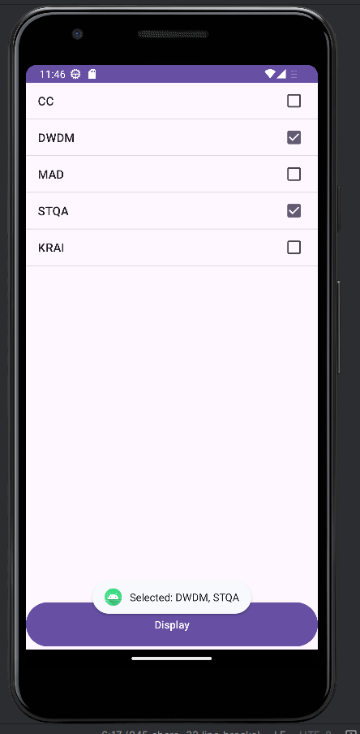

**06_08_2024_MAD_LECTURE – Q5**

Dropdown List using spinner

MainActivity.java

package com.example.a06_08_2024;  
  
import androidx.appcompat.app.AppCompatActivity;  
  
import android.os.Bundle;  
import android.view.View;  
import android.widget.AdapterView;  
import android.widget.ArrayAdapter;  
import android.widget.Spinner;  
import android.widget.Toast;  
  
public class MainActivity extends AppCompatActivity {  
  
 private Spinner spinner;  
  
 @Override  
 protected void onCreate(Bundle savedInstanceState) {  
 super.onCreate(savedInstanceState);  
 setContentView(R.layout.*activity_main*);  
  
 spinner = findViewById(R.id.*spinner*);  
  
 String[] items = {"CC", "DWDM", "STQA", "MAD", "KRAI"};  
 ArrayAdapter<String> adapter = new ArrayAdapter<>(this, android.R.layout.*simple_spinner_item*, items);  
 adapter.setDropDownViewResource(android.R.layout.*simple_spinner_dropdown_item*);  
 spinner.setAdapter(adapter);  
  
 spinner.setOnItemSelectedListener(new AdapterView.OnItemSelectedListener() {  
 @Override  
 public void onItemSelected(AdapterView<?> parent, View view, int position, long id) {  
 String selectedItem = parent.getItemAtPosition(position).toString();  
 Toast.*makeText*(MainActivity.this, "Selected item: " + selectedItem, Toast.*LENGTH_SHORT*).show();  
 }  
  
 @Override  
 public void onNothingSelected(AdapterView<?> parent) {  
 }  
 });  
 }  
}

activity_main.xml

<?xml version="1.0" encoding="utf-8"?>  
<LinearLayout xmlns:android="http://schemas.android.com/apk/res/android"  
 xmlns:app="http://schemas.android.com/apk/res-auto"  
 android:layout_width="match_parent"  
 android:layout_height="match_parent"  
 android:orientation="vertical">  
  
 <Spinner  
 android:id="@+id/spinner"  
 android:layout_width="match_parent"  
 android:layout_height="wrap_content" />  
  
</LinearLayout>

Output:

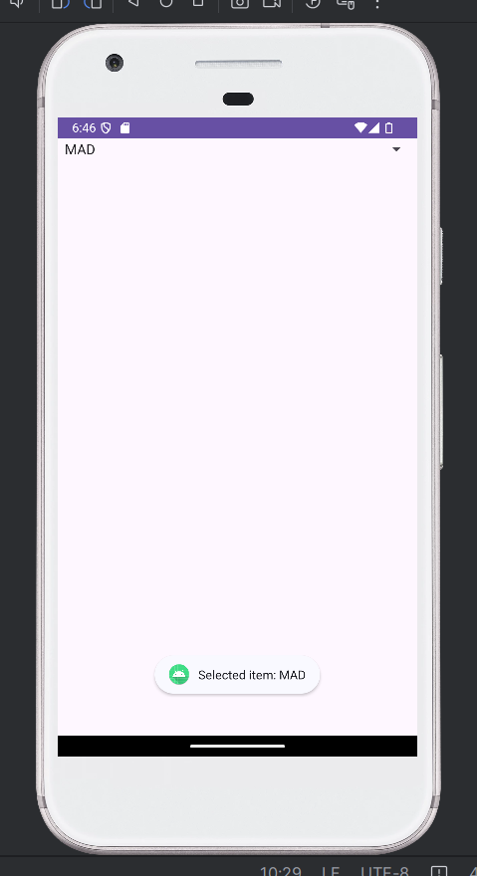 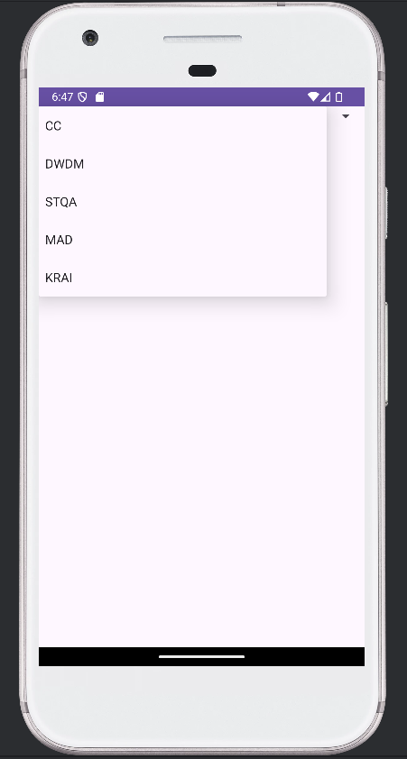

**09_08_2024_MAD_LECTURE – Q6**

Gridview using customadapter

MainActivity.java

package com.example.a09_08_2024;

import android.content.Intent;

import android.os.Bundle;

import android.text.method.HideReturnsTransformationMethod;

import android.text.method.PasswordTransformationMethod;

import android.view.View;

import android.widget.Button;

import android.widget.CheckBox;

import android.widget.EditText;

import android.widget.Toast;

import androidx.activity.EdgeToEdge;

import androidx.appcompat.app.AppCompatActivity;

public class MainActivity extends AppCompatActivity {

Button submit;

EditText user, pass;

private CheckBox showpass;

@Override

protected void onCreate(Bundle savedInstanceState) {

super.onCreate(savedInstanceState);

EdgeToEdge.enable(this);

setContentView(R.layout.activity_main);

submit = (Button) findViewById(R.id.loginButton);

user = (EditText) findViewById(R.id.username);

pass = (EditText) findViewById(R.id.password);

showpass = findViewById(R.id.showPassword);

showpass.setOnCheckedChangeListener((buttonView, isChecked) -> {

if (isChecked) {

// Show Password

pass.setTransformationMethod(HideReturnsTransformationMethod.getInstance());

} else {

// Hide Password

pass.setTransformationMethod(PasswordTransformationMethod.getInstance());

}

});

submit.setOnClickListener(new View.OnClickListener() {

@Override

public void onClick(View view) {

String username = user.getText().toString();

String password = pass.getText().toString();

if (username.equals("SIMMC") && password.equals("12345")) {

Intent intent = new Intent(MainActivity.this, MainActivity2.class);

startActivity(intent);

finish();

} else {

Toast.makeText(MainActivity.this, "Invalid username and password", Toast.LENGTH_SHORT).show();

}

}

});

}

}

activity_main.xml

<?xml version="1.0" encoding="utf-8"?>

<RelativeLayout xmlns:android="http://schemas.android.com/apk/res/android"

xmlns:app="http://schemas.android.com/apk/res-auto"

xmlns:tools="http://schemas.android.com/tools"

android:id="@+id/main"

android:layout_width="match_parent"

android:layout_height="match_parent"

tools:context=".MainActivity">

<LinearLayout

android:layout_width="match_parent"

android:layout_height="match_parent"

android:orientation="vertical"

android:gravity="center_horizontal">

<TextView

android:layout_width="wrap_content"

android:layout_height="wrap_content"

android:text="Login Form"

android:layout_marginTop="80dp"

android:textSize="24sp"

android:layout_gravity="center_horizontal"/>

<EditText

android:id="@+id/username"

android:layout_width="match_parent"

android:layout_height="wrap_content"

android:layout_margin="16dp"

android:layout_marginTop="50dp"

android:hint="Username"

android:inputType="text" />

<EditText

android:id="@+id/password"

android:layout_width="match_parent"

android:layout_height="wrap_content"

android:hint="Password"

android:layout_margin="16dp"

android:inputType="textPassword" />

<CheckBox

android:id="@+id/showPassword"

android:layout_width="wrap_content"

android:layout_height="wrap_content"

android:text="Show Password"

android:layout_gravity="center"/>

<Button

android:id="@+id/loginButton"

android:layout_width="match_parent"

android:layout_height="wrap_content"

android:layout_margin="16dp"

android:text="Login" />

</LinearLayout>

</RelativeLayout>

MainActivity2.java

package com.example.a09_08_2024;

import android.annotation.SuppressLint;

import android.content.Intent;

import android.os.Bundle;

import android.view.View;

import android.widget.Button;

import android.widget.RadioButton;

import android.widget.RadioGroup;

import android.widget.TextView;

import android.widget.Toast;

import androidx.appcompat.app.AppCompatActivity;

public class MainActivity2 extends AppCompatActivity {

private TextView questionText;

private RadioGroup answersGroup;

private Button nextButton;

private String[] questions = {

"What is the capital of France?",

"Who is the creator of Android?",

"What is the largest planet in our solar system?",

"Which language is used for Android development?",

"Display anything in java?"

};

private String[][] answers = {

{"Berlin", "Madrid", "Paris", "Lisbon"},

{"Steve Jobs", "Andy Rubin", "Mark Zuckerberg", "Bill Gates"},

{"Earth", "Mars", "Jupiter", "Saturn"},

{"Java", "Python", "C#", "Ruby"},

{"printf", "println", "print", "display"}

};

private int[] correctAnswers = {2, 1, 2, 0,2};

private int currentQuestionIndex = 0;

private int score = 0;

@SuppressLint("MissingInflatedId")

@Override

protected void onCreate(Bundle savedInstanceState) {

super.onCreate(savedInstanceState);

setContentView(R.layout.activity_main2);

questionText = findViewById(R.id.question);

answersGroup = findViewById(R.id.answersGroup);

nextButton = findViewById(R.id.nextButton);

loadQuestion();

nextButton.setOnClickListener(new View.OnClickListener() {

@Override

public void onClick(View v) {

int selectedId = answersGroup.getCheckedRadioButtonId();

if (selectedId == -1) {

Toast.makeText(MainActivity2.this, "Please select an answer", Toast.LENGTH_SHORT).show();

} else {

RadioButton selectedRadioButton = findViewById(selectedId);

int answerIndex = answersGroup.indexOfChild(selectedRadioButton);

if (answerIndex == correctAnswers[currentQuestionIndex]) {

score++;

}

currentQuestionIndex++;

if (currentQuestionIndex < questions.length) {

loadQuestion();

} else {

Intent intent = new Intent(MainActivity2.this, MainActivity3.class);

intent.putExtra("SCORE", score);

startActivity(intent);

finish();

}

}

}

});

}

private void loadQuestion() {

questionText.setText(questions[currentQuestionIndex]);

answersGroup.clearCheck();

for (int i = 0; i < answersGroup.getChildCount(); i++) {

((RadioButton) answersGroup.getChildAt(i)).setText(answers[currentQuestionIndex][i]);

}

}

}

activity_main2.xml

<?xml version="1.0" encoding="utf-8"?>

<LinearLayout xmlns:android="http://schemas.android.com/apk/res/android"

android:layout_width="match_parent"

android:layout_height="match_parent"

android:orientation="vertical"

android:padding="16dp">

<TextView

android:id="@+id/question"

android:layout_width="wrap_content"

android:layout_height="wrap_content"

android:text="Question will appear here"

android:textSize="18sp"

android:layout_marginBottom="16dp" />

<RadioGroup

android:id="@+id/answersGroup"

android:layout_width="wrap_content"

android:layout_height="wrap_content"

android:orientation="vertical">

<RadioButton

android:id="@+id/answer1"

android:layout_width="wrap_content"

android:layout_height="wrap_content"

android:text="Answer 1" />

<RadioButton

android:id="@+id/answer2"

android:layout_width="wrap_content"

android:layout_height="wrap_content"

android:text="Answer 2" />

<RadioButton

android:id="@+id/answer3"

android:layout_width="wrap_content"

android:layout_height="wrap_content"

android:text="Answer 3" />

<RadioButton

android:id="@+id/answer4"

android:layout_width="wrap_content"

android:layout_height="wrap_content"

android:text="Answer 4" />

</RadioGroup>

<Button

android:id="@+id/nextButton"

android:layout_width="wrap_content"

android:layout_height="wrap_content"

android:text="Next"

android:layout_marginTop="16dp" />

</LinearLayout>

MainActivity3.java

package com.example.a09_08_2024;

import android.annotation.SuppressLint;

import android.os.Bundle;

import android.content.Intent;

import android.view.View;

import android.widget.Button;

import android.widget.TextView;

import androidx.activity.EdgeToEdge;

import androidx.appcompat.app.AppCompatActivity;

public class MainActivity3 extends AppCompatActivity {

private TextView resultText;

private Button restartButton;

@SuppressLint("MissingInflatedId")

@Override

protected void onCreate(Bundle savedInstanceState) {

super.onCreate(savedInstanceState);

EdgeToEdge.enable(this);

setContentView(R.layout.activity_main3);

resultText = findViewById(R.id.result);

restartButton = findViewById(R.id.restartButton);

int score = getIntent().getIntExtra("SCORE", 0);

resultText.setText("Your score is: " + score);

restartButton.setOnClickListener(new View.OnClickListener() {

@Override

public void onClick(View v) {

Intent intent = new Intent(MainActivity3.this, MainActivity2.class);

startActivity(intent);

finish();

}

});

}

}

activity_main3.xml

<?xml version="1.0" encoding="utf-8"?>

<LinearLayout xmlns:android="http://schemas.android.com/apk/res/android"

android:layout_width="match_parent"

android:layout_height="match_parent"

android:orientation="vertical"

android:padding="16dp">

<TextView

android:id="@+id/result"

android:layout_width="wrap_content"

android:layout_height="wrap_content"

android:text="Your score is:"

android:textSize="28sp"

android:layout_marginTop="50dp"

android:layout_marginBottom="16dp" />

<Button

android:id="@+id/restartButton"

android:layout_width="wrap_content"

android:layout_height="wrap_content"

android:text="Restart Quiz"

android:layout_marginTop="16dp" />

</LinearLayout>

Output:

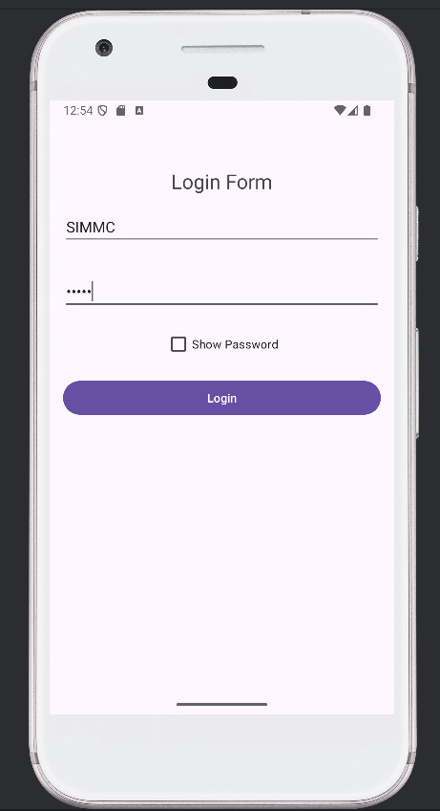 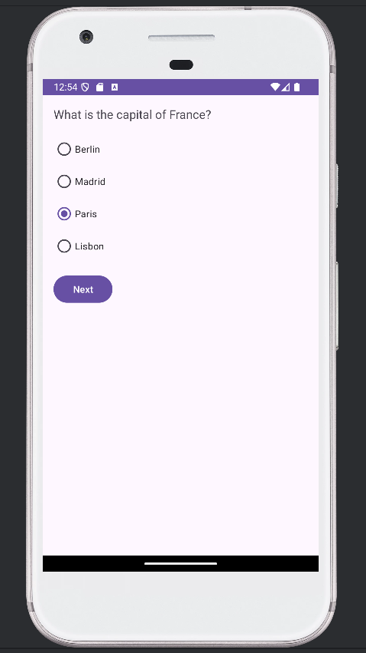

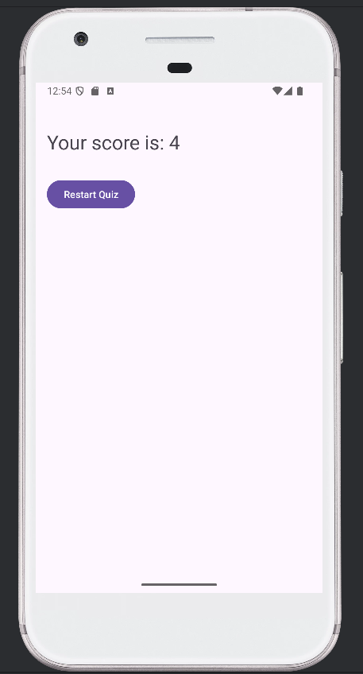

**12_08_2024_MAD_LECTURE – Q7**

Gridview using customadapter

MainActivity.java

package com.example.a12_08_2024;

import android.os.Bundle;

import android.view.View;

import android.widget.AdapterView;

import android.widget.GridView;

import android.widget.Toast;

import androidx.activity.EdgeToEdge;

import androidx.appcompat.app.AppCompatActivity;

import androidx.core.graphics.Insets;

import androidx.core.view.ViewCompat;

import androidx.core.view.WindowInsetsCompat;

public class MainActivity extends AppCompatActivity {

int food[]={R.drawable.apple,R.drawable.banana,R.drawable.orange,

R.drawable.carrot,R.drawable.eggplant,R.drawable.tomato,

R.drawable.mango,R.drawable.chickoo,R.drawable.watermelon

};

String[] names = {"Apple","Banana","Orange",

"Carrot","Eggplant","Tomato",

"Mango","Chickoo","Watermelon"

};

GridView gridView;

@Override

protected void onCreate(Bundle savedInstanceState) {

super.onCreate(savedInstanceState);

setContentView(R.layout.activity_main);

gridView = (android.widget.GridView) findViewById(R.id.gridview);

CustomAdapter customAdapter = new CustomAdapter(getApplicationContext(),food);

gridView.setAdapter(customAdapter);

gridView.setOnItemClickListener(new AdapterView.OnItemClickListener() {

@Override

public void onItemClick(AdapterView<?> adapterView, View view, int i, long l) {

Toast.makeText(MainActivity.this,"You choose " + names[i],Toast.LENGTH_LONG).show();

}

});

}

}

activity_main.xml

<?xml version="1.0" encoding="utf-8"?>

<LinearLayout xmlns:android="http://schemas.android.com/apk/res/android"

xmlns:app="http://schemas.android.com/apk/res-auto"

xmlns:tools="http://schemas.android.com/tools"

android:id="@+id/main"

android:layout_width="match_parent"

android:layout_height="match_parent"

tools:context=".MainActivity">

<GridView

android:layout_width="wrap_content"

android:layout_height="wrap_content"

android:id="@+id/gridview"

android:numColumns="3"

/>

</LinearLayout>

CustomAdapter.java

package com.example.a12_08_2024;

import android.content.Context;

import android.view.LayoutInflater;

import android.view.View;

import android.view.ViewGroup;

import android.widget.BaseAdapter;

import android.widget.ImageView;

public class CustomAdapter extends BaseAdapter {

Context context;

int images[];

LayoutInflater inflater;

public CustomAdapter(Context applicationContext, int[] images){

this.context=applicationContext;

this.images=images;

inflater = (LayoutInflater.from(applicationContext));

}

@Override

public int getCount() {

return images.length;

}

@Override

public Object getItem(int i) {

return null;

}

@Override

public long getItemId(int i) {

return 0;

}

@Override

public View getView(int i, View view, ViewGroup viewGroup) {

view = inflater.inflate(R.layout.images,null);

ImageView imageView = (ImageView) view.findViewById(R.id.imageView);

imageView.setImageResource(images[i]);

return view;

}

}

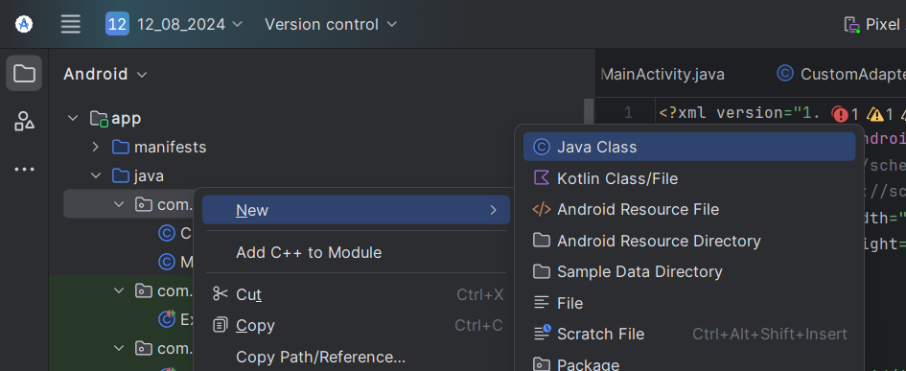

images.xml

<?xml version="1.0" encoding="utf-8"?>  
<LinearLayout xmlns:android="http://schemas.android.com/apk/res/android"  
 xmlns:app="http://schemas.android.com/apk/res-auto"  
 xmlns:tools="http://schemas.android.com/tools"  
 android:layout_width="match_parent"  
 android:layout_height="match_parent"  
 >  
 <ImageView  
 android:id="@+id/imageView"  
 android:layout_gravity="center_horizontal"  
 android:layout_width="100dp"  
 android:layout_height="100dp"  
 android:scaleType="fitXY"/>  
 />  
</LinearLayout>

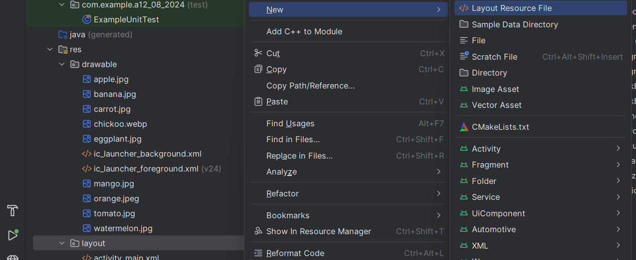

Output:

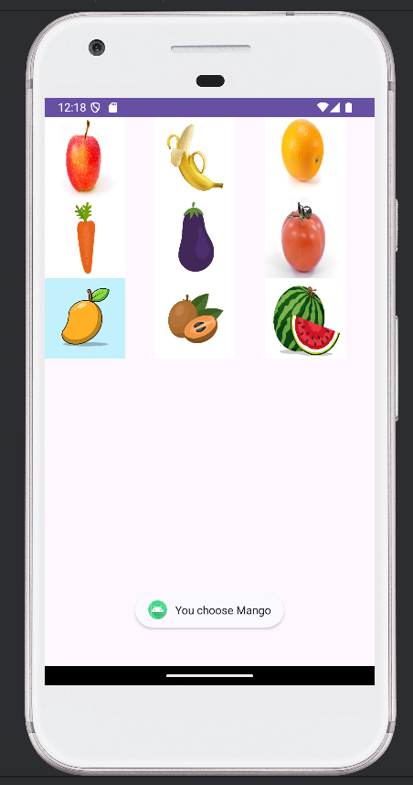 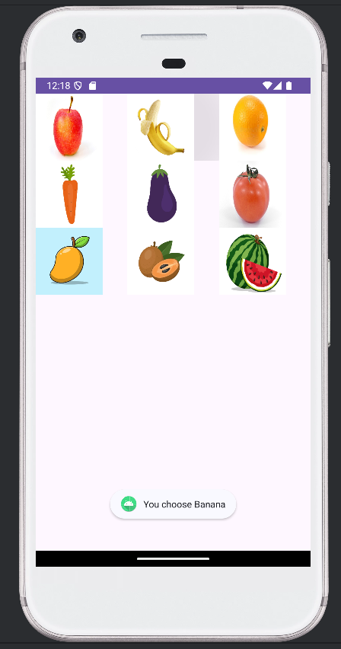

**13_08_2024_MAD_Lecture – Q8**

MainActivity.java

package com.example.a13_08_2024_dialog;

import android.content.DialogInterface;

import android.os.Bundle;

import android.view.View;

import android.widget.Button;

import android.widget.Toast;

import androidx.activity.EdgeToEdge;

import androidx.appcompat.app.AlertDialog;

import androidx.appcompat.app.AppCompatActivity;

import androidx.core.graphics.Insets;

import androidx.core.view.ViewCompat;

import androidx.core.view.WindowInsetsCompat;

public class MainActivity extends AppCompatActivity {

@Override

protected void onCreate(Bundle savedInstanceState) {

super.onCreate(savedInstanceState);

setContentView(R.layout.activity_main);

Button alert=(Button) findViewById(R.id.b1);

alert.setOnClickListener(new View.OnClickListener() {

@Override

public void onClick(View v) {

AlertDialog.Builder builder = new AlertDialog.Builder(MainActivity.this);

builder.setMessage("DO You Want To Close This Application ?")

.setCancelable(true)

.setPositiveButton("yes", new DialogInterface.OnClickListener() {

@Override

public void onClick(DialogInterface dialogInterface, int i) {

finish();

Toast.makeText(getApplicationContext(),"You choose yes action for alertbox", Toast.LENGTH_SHORT).show();

}

})

.setNegativeButton("No", new DialogInterface.OnClickListener() {

@Override

public void onClick(DialogInterface dialog, int i) {

dialog.cancel();

Toast.makeText(getApplicationContext(),"You choose No action for alertbox", Toast.LENGTH_SHORT).show();

}

})

.setTitle("Alert Box").show();

}

});

}

}

activity_main.xml

<?xml version="1.0" encoding="utf-8"?>

<RelativeLayout xmlns:android="http://schemas.android.com/apk/res/android"

xmlns:app="http://schemas.android.com/apk/res-auto"

xmlns:tools="http://schemas.android.com/tools"

android:id="@+id/main"

android:layout_width="match_parent"

android:layout_height="match_parent"

tools:context=".MainActivity">

<Button

android:id="@+id/b1"

android:layout_width="wrap_content"

android:layout_height="wrap_content"

android:layout_alignParentEnd="true"

android:layout_alignParentBottom="true"

android:layout_marginEnd="189dp"

android:layout_marginBottom="431dp"

android:text="Button" />

</RelativeLayout>

Output:

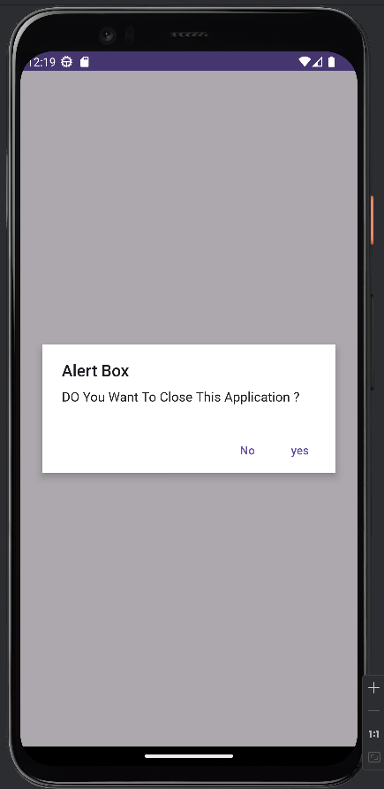 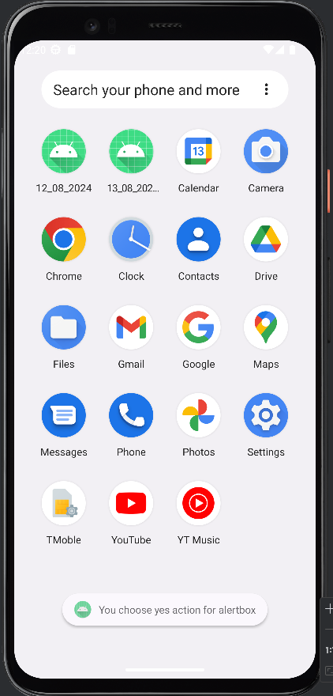 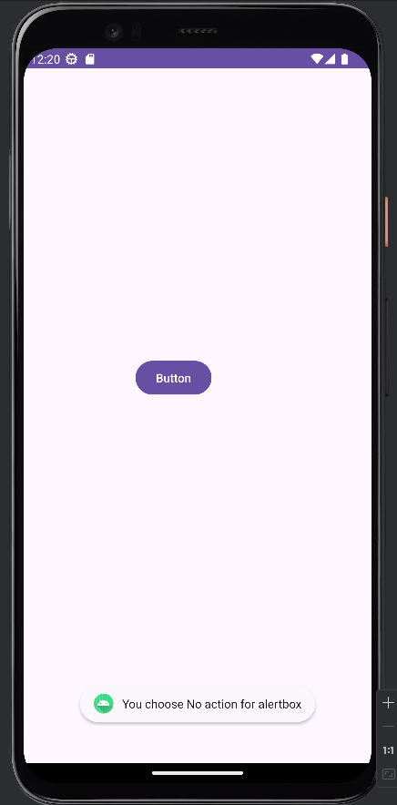

**16_08_2024_MAD_Lecture – Q9**

MainActivity.java

package com.example.a16_08_2024;

import android.content.DialogInterface; import android.os.Bundle;

import android.view.View; import android.widget.Button;

import android.widget.Toast;

import androidx.activity.EdgeToEdge;

import androidx.appcompat.app.AlertDialog;

import androidx.appcompat.app.AppCompatActivity; import androidx.core.graphics.Insets;

import androidx.core.view.ViewCompat;

import androidx.core.view.WindowInsetsCompat;

import java.util.ArrayList;

public class MainActivity extends AppCompatActivity {

Button btn,btn2;

String toppings[] = {"Cheese","Paneer","Mushroom","Capsicum","Onion","Corn"}; ArrayList<Integer> arlist = new ArrayList<>();

String msg="";

boolean [] Vb = new boolean[toppings.length]; int ai=0;

@Override

protected void onCreate(Bundle savedInstanceState) { super.onCreate(savedInstanceState); EdgeToEdge.enable(this); setContentView(R.layout.activity_main);

btn = (Button) findViewById(R.id.btn1); btn2 = (Button) findViewById(R.id.btn2);

btn.setOnClickListener(new View.OnClickListener() { @Override

public void onClick(View v) {

AlertDialog.Builder builder = new AlertDialog.Builder(MainActivity.this); builder.setTitle("Choice Toppings.");

builder.setMultiChoiceItems(toppings,Vb, new DialogInterface.OnMultiChoiceClickListener() {

@Override

public void onClick(DialogInterface dialog, int i, boolean isChecked) { if (isChecked){

arlist.add(i);

} else if (arlist.contains(i)) { arlist.remove(Integer.valueOf(i));

}

}

})

.setPositiveButton("Yes", new DialogInterface.OnClickListener() { @Override

public void onClick(DialogInterface dialog, int which) { for (int a=0; a<arlist.size(); a++){

msg = msg+"\n"+": "+toppings[arlist.get(a)];

}

Toast.makeText(getApplicationContext(),"Total Toppings Selected:"+arlist.size(),Toast.LENGTH_LONG).show();

}

})

.setNegativeButton("No", new DialogInterface.OnClickListener() { @Override

public void onClick(DialogInterface dialog, int which) { dialog.dismiss();

Toast.makeText(getApplicationContext(),"No Toppings Selected",Toast.LENGTH_LONG).show();

}

});

AlertDialog ad= builder.create(); ad.show();

}

});

btn2.setOnClickListener(new View.OnClickListener() { @Override

public void onClick(View v) {

AlertDialog.Builder builder2 = new AlertDialog.Builder(MainActivity.this); builder2.setTitle("Single")

.setSingleChoiceItems(toppings, 0, new DialogInterface.OnClickListener() { @Override

public void onClick(DialogInterface dialog, int which) { ai=which;

}

})

.setPositiveButton("Yes", new DialogInterface.OnClickListener() { @Override

public void onClick(DialogInterface dialog, int which) {

Toast.makeText(MainActivity.this, "Selected item"+toppings[ai], Toast.LENGTH_SHORT).show();

}

})

.setNegativeButton("No", new DialogInterface.OnClickListener() { @Override

public void onClick(DialogInterface dialog, int which) { Toast.makeText(getApplicationContext(),"Sorry",Toast.LENGTH_LONG).show();

}

});

AlertDialog ad= builder2.create(); ad.show();

}

});

}

}

activity_main.xml

<?xml version="1.0" encoding="utf-8"?>

<RelativeLayout xmlns:android="http://schemas.android.com/apk/res/android"

xmlns:app="http://schemas.android.com/apk/res-auto"

xmlns:tools="http://schemas.android.com/tools"

android:id="@+id/main"

android:layout_width="match_parent"

android:layout_height="match_parent"

tools:context=".MainActivity"

android:orientation="vertical">

<Button

android:id="@+id/btn1"

android:layout_width="match_parent"

android:layout_height="wrap_content"

android:layout_alignParentTop="true"

android:layout_alignParentEnd="true"

android:layout_marginTop="206dp"

android:layout_marginEnd="1dp"

android:text="Select Toppings"

tools:layout_editor_absoluteX="144dp"

tools:layout_editor_absoluteY="58dp" />

<Button

android:id="@+id/btn2"

android:layout_width="match_parent"

android:layout_height="wrap_content"

android:layout_alignParentTop="true"

android:layout_alignParentEnd="true"

android:layout_marginTop="298dp"

android:layout_marginEnd="0dp"

android:text="Select Single Toppings"

tools:layout_editor_absoluteX="144dp"

tools:layout_editor_absoluteY="58dp" />

</RelativeLayout>

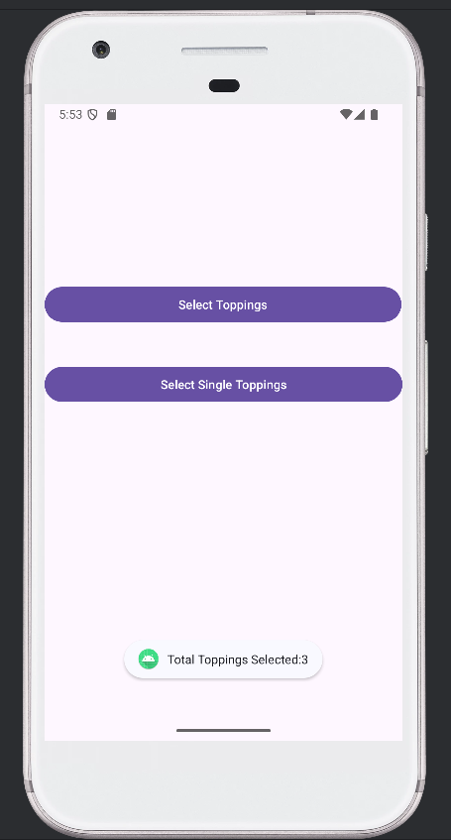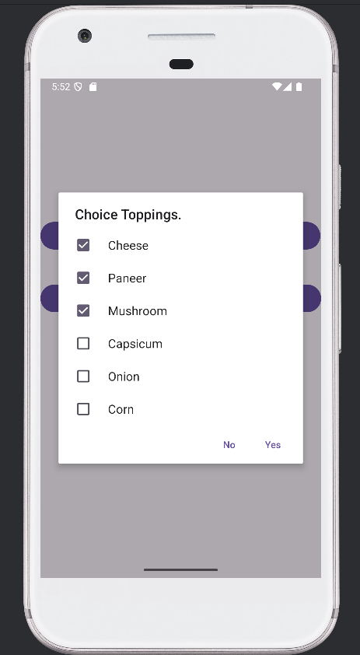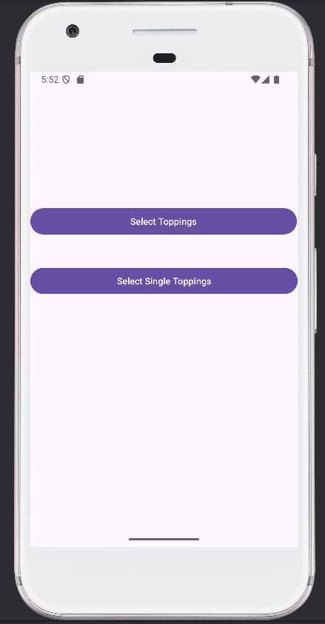Output:

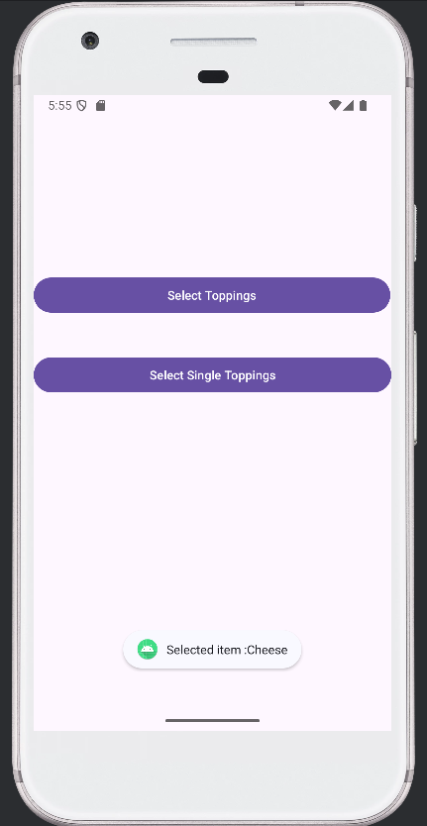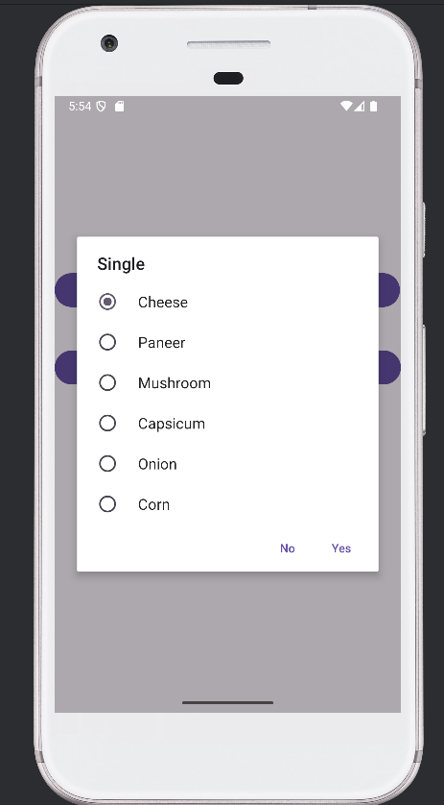

**20_08_2024_MAD_Lecture – Q10**

Date Picker using toast

MainActivity.java

package com.example.a20_08_2024;

import android.os.Bundle;

import android.view.View;

import android.widget.Button;

import android.widget.DatePicker;

import android.widget.Toast;

import androidx.activity.EdgeToEdge;

import androidx.appcompat.app.AppCompatActivity;

import androidx.core.graphics.Insets;

import androidx.core.view.ViewCompat;

import androidx.core.view.WindowInsetsCompat;

public class MainActivity extends AppCompatActivity {

Button btn;

DatePicker dt;

@Override

protected void onCreate(Bundle savedInstanceState) {

super.onCreate(savedInstanceState);

setContentView(R.layout.activity_main);

btn =(Button) findViewById(R.id.b1);

dt = (DatePicker) findViewById(R.id.dpicker);

btn.setOnClickListener(new View.OnClickListener() {

@Override

public void onClick(View view) {

Toast.makeText(MainActivity.this, "Selected date is "+dt.getDayOfMonth()+"/" +(dt.getMonth()+1)+"/" +dt.getYear() ,Toast.LENGTH_SHORT).show();

}

});

}

}

Activity_main.xml

<?xml version="1.0" encoding="utf-8"?>

<RelativeLayout xmlns:android="http://schemas.android.com/apk/res/android"

xmlns:app="http://schemas.android.com/apk/res-auto"

xmlns:tools="http://schemas.android.com/tools"

android:id="@+id/main"

android:layout_width="match_parent"

android:layout_height="match_parent"

android:orientation="vertical"

tools:context=".MainActivity">

<Button

android:id="@+id/b1"

android:layout_width="match_parent"

android:layout_height="59dp"

android:layout_alignParentEnd="true"

android:layout_alignParentBottom="true"

android:layout_marginEnd="0dp"

android:layout_marginBottom="162dp"

android:layout_weight="1"

android:fontFamily="garamond"

android:text="select date"

/>

<DatePicker

android:id="@+id/dpicker"

android:layout_width="match_parent"

android:layout_height="wrap_content"

android:layout_alignParentStart="true"

android:layout_alignParentEnd="true"

android:layout_alignParentBottom="true"

android:layout_gravity="center"

android:layout_marginStart="0dp"

android:layout_marginEnd="0dp"

android:layout_marginBottom="299dp" />

</RelativeLayout>

Output:

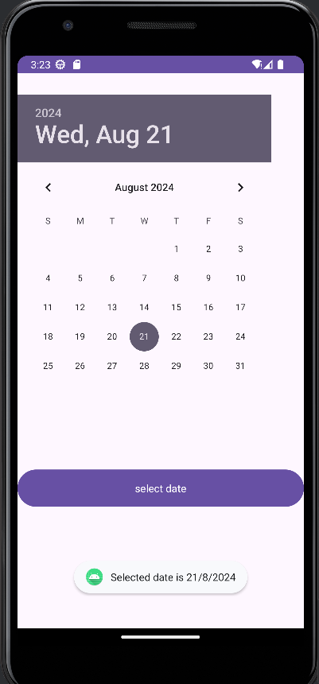

**27_08_2024_MAD_Lecture – Q11**

Menu - Pop Up

MainActivty.java

package com.example.a27_08_2024;

import android.content.Intent;

import android.os.Bundle;

import android.view.MenuItem;

import android.view.View;

import android.widget.Button;

import android.widget.PopupMenu;

import android.widget.Toast;

import androidx.activity.EdgeToEdge;

import androidx.appcompat.app.AppCompatActivity;

import androidx.core.graphics.Insets;

import androidx.core.view.ViewCompat;

import androidx.core.view.WindowInsetsCompat;

public class MainActivity extends AppCompatActivity {

@Override

protected void onCreate(Bundle savedInstanceState) {

super.onCreate(savedInstanceState);

setContentView(R.layout.activity_main);

Button btn= (Button)findViewById(R.id.button);

btn.setOnLongClickListener(new View.OnLongClickListener() {

@Override

public boolean onLongClick(View view) {

PopupMenu p = new PopupMenu(MainActivity.this, btn);

p.getMenuInflater().inflate(R.menu.popup_m, p.getMenu());

p.setOnMenuItemClickListener(new PopupMenu.OnMenuItemClickListener() {

@Override

public boolean onMenuItemClick(MenuItem menuItem) {

String menu=menuItem.getTitle().toString();

if(menu.equals("two")){

Intent i = new Intent(getApplicationContext(), second.class);

startActivity(i);

}

else {

Toast.makeText(MainActivity.this, "You Clicked on " + menuItem.getTitle(), Toast.LENGTH_SHORT).show();

}

return true;

}

});

p.show();

return true;

}

});

}

}

activity_main.xml

<?xml version="1.0" encoding="utf-8"?>

<RelativeLayout xmlns:android="http://schemas.android.com/apk/res/android"

xmlns:app="http://schemas.android.com/apk/res-auto"

xmlns:tools="http://schemas.android.com/tools"

android:id="@+id/main"

android:layout_width="match_parent"

android:layout_height="match_parent"

tools:context=".MainActivity">

<Button

android:id="@+id/button"

android:layout_width="wrap_content"

android:layout_height="wrap_content"

android:layout_alignParentEnd="true"

android:layout_alignParentBottom="true"

android:layout_marginEnd="152dp"

android:layout_marginBottom="408dp"

android:text="POP - UP" />

</RelativeLayout>

Second.java

package com.example.a27_08_2024;

import android.os.Bundle;

import androidx.activity.EdgeToEdge;

import androidx.appcompat.app.AppCompatActivity;

import androidx.core.graphics.Insets;

import androidx.core.view.ViewCompat;

import androidx.core.view.WindowInsetsCompat;

public class second extends AppCompatActivity {

@Override

protected void onCreate(Bundle savedInstanceState) {

super.onCreate(savedInstanceState);

setContentView(R.layout.activity_second);

}

}

activity_second.xml

<?xml version="1.0" encoding="utf-8"?>

<RelativeLayout xmlns:android="http://schemas.android.com/apk/res/android"

xmlns:app="http://schemas.android.com/apk/res-auto"

xmlns:tools="http://schemas.android.com/tools"

android:id="@+id/main"

android:layout_width="match_parent"

android:layout_height="match_parent"

tools:context=".second">

<TextView

android:id="@+id/textView"

android:layout_width="wrap_content"

android:layout_height="wrap_content"

android:layout_alignParentEnd="true"

android:layout_alignParentBottom="true"

android:layout_marginEnd="137dp"

android:layout_marginBottom="402dp"

android:gravity="center_horizontal"

android:text="Second Page"

android:textColor="#16A435"

android:textSize="30dp"

tools:layout_editor_absoluteX="183dp"

tools:layout_editor_absoluteY="308dp" />

</RelativeLayout>

Output:

